# Webpart to API Converter

Kentico has many great tools that allow users to display their web content in many different ways. However, there lacks a way to leverage this to create Web API calls. This web part converter bridges that gap, by allowing you to select a Web part on a page to act as that page’s only output. Given the WebpartID (coupled with the content-type), it clears all the response content except what that web part renders.

Some applications of this web part can be:

* Apply to a Smart Search results to create an api for ajax “suggested search” results.
* Apply to a Repeater or Hierarchy Viewer to create an API to retrieve objects in JSON
* Apply to a Custom Table Repeater to turn your database into a queryable API or XML feed.
* Apply to an Events Repeater to create an events subscription page or event file (ics)

It should be noted that some of the functionality of this Web Part are similar to the XML Repeater and Atom Repeater, but this Web Part does not rely on a Data Source, but instead can be applied to a wider variety of Web Parts and can output in a wider variety of formats and Content Types (ex: JSON)

## Application

The Web part to API has a couple options.

* **Webpart ID**: This is the value of the web part that you wish to convert.
* **Content Type**: This is the content type you wish the content to be presented as. You can add more content types simply by editing the web part’s field drop down values.
* **Render as Attachment with Filename:** If a file name is provided, the output will be rendered as an attachment and the user will be prompted to open or save. Useful for .ICS event exports or XML Exports.
* **Content Before Results**: Content that will be placed before the Web part’s content.
  + This is useful in things like Repeaters as you can have the Repeater display each item, and the Web part to API Convert wrap that.
* **Content After Results**: Content that will be placed after the Web part’s Content

The Webpart to API converter does not alter the content (except when the content type is application/json, in which case the code will remove any HTML elements, requiring content to be HTML encoded prior. See transformation samples), so it is important that you set any transformations to output exactly as you want it to display in the API.

Included with this webpart is a Page Type (WebpartToAPI.SampleTransformations) that contains sample transformations for each of the below Sample/Cases and should get you started.

There is one Code file included (WebpartToAPIHelper.cs) included which contains some functions for the ICS rendering.

Any Questions or bugs, please contact [tfayas@avastonetech.com](mailto:tfayas@avastonetech.com)

## Installation

1: Sites -> Import site or objects. Upload the WebpartToAPIConverter.zip and hit next.  
2: Please be sure when importing this asset to check “Import Files (recommended)” and all 3 checkboxes below.  
3: Ensure under All Objects -> Global Objects -> Development, that all items are selected.

## Samples / Case Instructions

To help users understand how to set their transformations up, there is a Custom Doc Type included with the Web Part that contains sample transformations for various commonly used items, such as Repeaters, Hierarchy Viewers, and Smart Search Results.

### For Smart Search Results

1. Add a Smart Search Results Webpart to a page, setting it up as you would normally.
2. Add the following configurations:
   1. Set the transformation to WebpartToAPI.SampleTransformations.SmartSearchResultsJSON - OR - WebpartToAPI.SampleTransformations.SmartSearchResultsXML
   2. Set the “No results text ” to: {"Title": "No Results Found"} or </SearchResult>
3. Add a WebpartToAPI Converter Web Part
4. Configure as follows:
   1. Set the WebpartID to the ID of the Smart Search Results
   2. For JSON output:
      1. Set the Content Type to application/json
      2. For the Content Before Results, set to: {“SearchResults”:[
      3. For the Content After Results, set to: ]}
   3. For XML Output:
      1. Set the Content Type to text/xml
      2. For the Content Before Results, set to: <SearchResults>
      3. For the Content After Results, set to: </SearchResults>
5. Lastly, reference that page as you would a normal search results, with the searchtext and searchmode in the URL.
   1. Ex: /MySearchAPI.aspx?searchtext=Some%20Search%20Text&searchmode=anyword

NOTE: For Smart Search Results, the Smart Search Results Web Part will force its outer <div> into the results. The WebpartToAPI strips all HTML for the *JSON results*, so this is removed, however for text/xml and other content types, it is not stripped. It should not affect your API however as it is still valid XML, and will render similar to the below:

<SearchResults>  
 <div id=”p_lt_ctl01_SmartSearchResults_srchResults_pnlSEarchResults”>  
 <SearchResult>…</SearchResult>  
 <SearchResult>…</SearchResult>  
 </div>  
 </SearchResults>

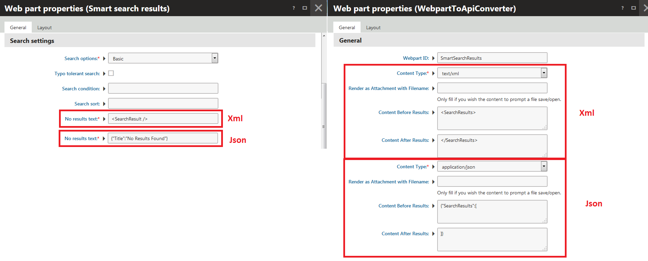

### For Repeaters / Repeater with Custom Query

For Repeaters, you will most likely need to adjust the Sample Transformations to match the Item Structure you are referring to. Please feel free to clone the WebpartToAPI.SampleTransformations.RepeaterArticleJSON or WebpartToAPI.SampleTransformations.RepeaterArticleXML and adjust to your needs.

1. Add a Repeater (or similar) Web Part to the Page, setting up as you would normally.
2. Add the following Configurations:
   1. For JSON
      1. Set the Transformation to WebpartToAPI.SampleTransformations.RepeaterArticleJSON
      2. Set The Item Separator to a single comma: ,
      3. Set the No Data Behavior to either Hide if no record found, or a No Record found text to some valid JSON like : {“Error”: “No Documents Found”}
   2. For XML
      1. Set the Transformation to WebpartToAPI.SampleTransformations.RepeaterArticleXML
      2. Set the No Data Behavior to either Hide if no record found, or a No Record found text to some valid XML like: <Article></Article>
   3. Disabled Paging
3. Add a WebpartToAPI Convert Web Part
   1. Set the WebpartID to the ID of the Repeater
   2. For JSON Output:
      1. Set the Content type to application/json
      2. For the Content Before Results, set to: {“Items”:[
      3. For the Content After Results, set to: ]}
   3. For XML Output
      1. Set the Content Type to text/xml
      2. For the Content Before, set to: <Items>
      3. For the Content After, set to: </Items>

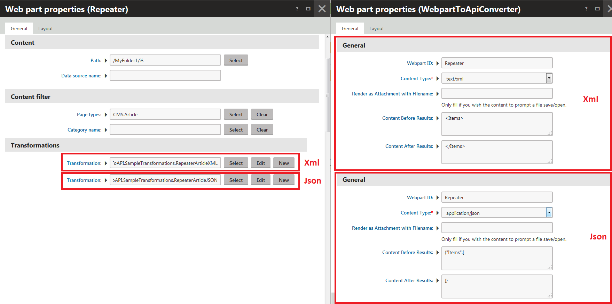

### For Hierarchy Viewers

For Hierarchy Viewers, you will most likely need to adjust the Sample Transformations to match the Item Structure you are referring to. Please feel free to clone the WebpartToAPI.SampleTransformations.HierarchyViewerJson or WebpartToAPI.SampleTransformations.HierarchyViewerXML and adjust to your needs. Be sure to adjust the sub items as well.

1. Add a Hierarchy Viewer Web Part to the Page, setting up as you would normally.
2. Add the following Configurations:
   1. For JSON
      1. Set the Transformation to WebpartToAPI.SampleTransformations.HierarchyViewerJSON
      2. Set the No Data Behavior to either Hide if no record found, or a No Record found text to some valid JSON like : {“Error”: “No Documents Found”}
   2. For XML
      1. Set the Transformation to WebpartToAPI.SampleTransformations.RepeaterArticleXML
      2. Set the No Data Behavior to either Hide if no record found, or a No Record found text to some valid XML like: <Article></Article>
   3. Disabled Paging
3. Add a WebpartToAPI Convert Web Part
   1. Set the WebpartID to the ID of the Repeater
   2. For the Content type, set to either application/json, or text/xml.
   3. For the Content Before Results, this can be blank as the “Before” content is defined in the Level 0 Header Transformation in the Hierarchy Transformation
   4. For the Content After Results, this can be blank as the “After” content is defined in the Level 0 Footer Transformation in the Hierarchy Transformation

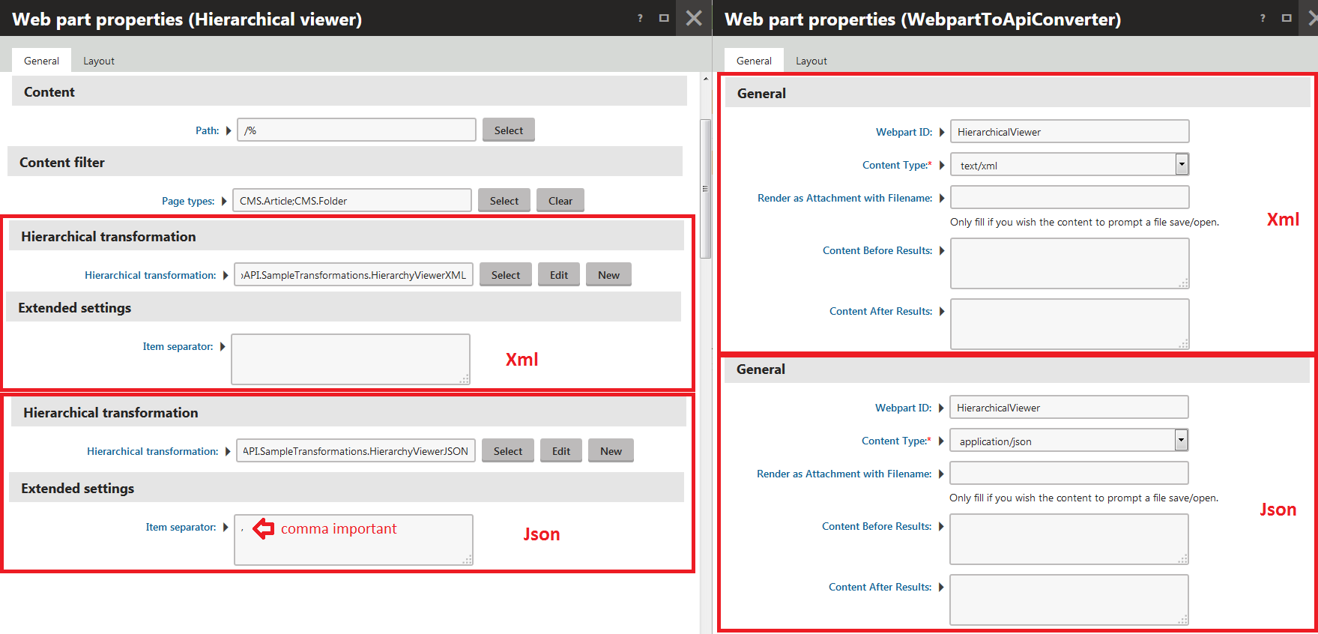

### For Events to ICS (Calendar)

In order to export a list of events (or a specific event) to Outlook or other Calendars, we format a repeater of events and export it either as a feed or as a file. Lastly, ICS integration is not an exact science, Outlook handles multiple events fine, where as other programs may not be able to import multiple events.

1. Add a Repeater Web Part to the Page, setting up as you would normally, pointing to either events or booking events (booking events will allow for start and end times).
2. Add the following Configurations:
   1. Set the Transformation to:
      1. WebpartToAPI.SampleTransformations.RepeaterBookingEventToICS - OR -
      2. WebpartToAPI.SampleTransformations.RepeaterEventToICS
   2. Set the No Data Behavior to either Hide if no record found
   3. Disabled Paging
3. Add a WebpartToAPI Convert Web Part
   1. Set the WebpartID to the ID of the Repeater
   2. For the Content type, set to either text/calendar.
   3. If you wish to have this export as a file (vs. a feed)
      1. For Render as Attachment with Filename, put a filename such as: events.ics
   4. For the Content Before Results, put the below 2 lines:
      1. BEGIN:VCALENDAR
      2. METHOD:PUBLISH
   5. For the Content After Results, put the below line:
      1. END:VCALENDAR
4. If you are exporting as a file, point the user to the page you just created to have them prompted to save the events file.
5. If you wish to have this as a web subscription instead, simply point to the page, using webcal:// instead of http:// as this will notify calendar clients that this is a events feed (so when the page changes as you add events, their clients should receive the updated events)

It should be noted that you can use the repeater’s WHERE Filter and URL Macros to make the ICS export either a specific event (by EventID) or a list.

* Example /SpecialPages/MyEventExport.aspx?eventID=123
* WHERE Statement of either:
  + BookingEventID = '{? eventID ?}' OR '' = '{? eventID ?}' - OR -
  + EventID = '{? eventID ?}' OR '' = '{? eventID ?}'

